Burton upon Stather Primary School

Pupil premium strategy statement
This statement details our school’s use of pupil premium funding to help improve the attainment of our disadvantaged pupils.
It outlines our pupil premium strategy, how we intend to spend the funding in this academic year and the outcomes for disadvantaged pupils last academic year.
School overview
Detail | Data
Number of pupils in school | 163
Proportion (%) of pupil premium eligible pupils | 17/163 (10.4%)
Academic year/years that our current pupil premium strategy plan covers (3-year plans are recommended – you must still publish an updated statement each academic year) | 2025 -26  2026 -27  2027 -28
Date this statement was published | Dec 2025
Date on which it will be reviewed | Dec 2026
Statement authorised by | S Woolley - Principal
Pupil premium lead | A Masoud
Governor / Trustee lead | R Scutt
Funding overview
Detail | Amount
Pupil premium funding allocation this academic year | £28785
Pupil premium funding carried forward from previous years (enter £0 if not applicable) | £0
Total budget for this academic year  If your school is an academy in a trust that pools this funding, state the amount available to your school this academic year | £28785
Part A: Pupil premium strategy plan
Statement of intent
At Burton upon Stather Primary School we believe that every child should be supported to achieve success academically, socially and emotionally, no matter what their background or barrier to learning. The targeted and strategic use of the Pupil Premium Grant (PPG) supports us in achieving this.
PURPOSE
- To ensure consistency in our approach to supporting children who are eligible for the PPG or considered as disadvantaged due to their current situation
- To outline the outcomes, we expect so that these can be closely monitored and evaluated

Our ultimate objectives are:
To ensure that teaching and learning opportunities meet the needs of all of our pupils. We ensure that appropriate provision is made for pupils who belong to vulnerable groups, this includes ensuring that the needs of socially disadvantaged pupils are adequately assessed and addressed. In making provision for socially disadvantaged pupils, we recognise that not all pupils who receive free school meals (FSM) will be socially disadvantaged. We also recognise that not all pupils who are socially disadvantaged are registered or qualify for FSM. We reserve the right to allow socially disadvantaged pupils to join in with activities or interventions initially created to support those in receipt of PPG. The PPG will be allocated following a needs analysis through data collection and pupil voice questionnaires, which will identify priority classes, groups or individuals. The amount of PPG is considered as a whole, rather than as an amount per child that must be accounted for.
We will achieve this by:
- Providing a range of provision that the school considers beneficial in closing the attainment gap:
- Providing small group work with an experienced teacher, focussed on overcoming barriers to learning.
- 1:1 or small group tuition, with a qualified teacher or staff member.
- The provision of specific or specialised equipment and resources.
- Additional teaching and learning opportunities provided through trained Teaching Assistants or external agencies (such as Get Ahead).
- Providing each child with enriching experiences, through targeted attendance within clubs, during and after school.
- Providing access to pastoral support for any child which requires it.
- Employing a skilled Pastoral Leader to support children and families.
- All our work through PPG will be aimed at accelerating progress form everyone from their relevant starting point(s).
- We strive to ensure all PPG pupils achieve in line with all non- disadvantaged pupils nationally.
- Initially the academic focus will be on reading, writing and maths and the social focus will be on behaviour and emotions. However, all learning and support is personalised and targeted to everyone.

Challenges
This details the key challenges to achievement that we have identified among our disadvantaged pupils.
Challenge number | Detail of challenge
1 | For many pupils, behaviour and positive attitudes to learning have impacted pupils' independence to their learning. Use of metacognition needed to raise attainment and support pupils.
2 | Pupil’s engagement and drive to achieve at a greater depth level within mathematics can be limited.
3 | For many pupils, there can be limited life experiences and opportunities to join in enrichment (including extra-curricular) opportunities due to homelife.
4 | Focus on reading for disadvantaged pupils through use of phonics to support them in accessing the full curriculum
Intended outcomes
This explains the outcomes we are aiming for by the end of our current strategy plan, and how we will measure whether they have been achieved.
Intended outcome | Success criteria
Continue to improve rates of progress so that all pupils make or exceed targets from relevant starting points across KS1 and KS2 in reading. | Teaching and learning are at least good across the curriculum with a consistent approach to teaching reading skills and comprehension.  Well planned cross-curricular learning across the curriculum to embed and deepen understanding and learning. Developing a reading rich curriculum using daily shared reading sessions, weekly comprehension lessons. Effective and monitored use of Reading Plus across KS2 to broaden pupils’ access to a wide range of literature. Access to ‘take home’ books in line with current phonics teaching to support and embed learning and understanding. Including magazine swap shop and books tailored to pupil interests. Termly pupil progress meetings to ensure progress and interventions are relevant and effective. Well, planned, timely intervention opportunities to close the gaps, such as precision teaching activities.
Improve levels of motivation and aspirations to achieve at a greater depth level in maths. | Weekly interventions in place to support working at a greater depth level within mathematics. Greater depth maths clubs implemented with invites to pupils to help motivate and promote a culture of achievement. Introduction of ‘maths ambassadors’ to support and promote a love of learning. Implementation of ‘Everyday I’m Calculatin’ across the school to ensure all children are accessing learning at a greater depth level, daily (and develop working memory). Termly drop-ins by Maths Lead to ensure children are being encouraged to achieve and promotion of aspirations in place in every class. Cross curricular approach to teaching of mathematics to ensure pupils are aware of mathematics in the wider world. Aspirational adults planned in and taught in every topic, eg: scientists, artists, mathematicians etc. AIM High Math Days attended at the Grange for KS1 and KS2 pupils
Access to trained Tas and class teachers to help improve self-esteem, resilience and aspirations and social skills | Pupils’ resilience and self-esteem are built upon to help prepare for secondary school and beyond. Pupils’ social skills are supported and promoted through adult intervention and attendance to Get Ahead sessions within school time and after school. Class teachers to implement purposeful and effective PSHCE lessons into their curriculum to promote resilience and aspirations within pupils. 1:1 and group sessions with pastoral lead to develop strategies to improve resilience and self-belief in possibilities within and beyond school. Whole class strategies implemented by class teachers to support resilience within pupils. Aspirational adults planned in and taught in every topic, eg: scientists, artists, mathematicians etc. Access to Theraplay and or Lego Therapy sessions.
Continue to improve pupils’ access to enrichment and life experiences within and out of school. | Continued subsidiary of experiences out of school.  Subsidised school trips, termly.  Subsidised piano, guitar, drums and Ukulele lessons within school.  Targeted access to the Get Ahead programme, termly.

Activity in this academic year
This details how we intend to spend our pupil premium funding this academic year to address the challenges listed above.
Teaching
Budgeted cost: £ 15,000
Activity | Evidence that supports this approach | Challenge number(s) addressed
High quality teaching through shared reading sessions led by class teacher | EEF – Feedback (+6 months)  EEF – Oral Language Interventions (+6 months)  EEF – Reading Comprehension Strategies (+6 months)  Improving Literacy in KS2 – guidance report | 4
Small group tuition, for greater depth maths following a mastery approach | EEF – Collaborative Learning Approaches  EEF – Mastery Learning Toolkit (+5 months) | 2, 1
Ensure training and staffing for the implementation and delivery of high quality RWI sessions  Staff trained by Ruth Miskin | EEF – Phonics Toolkit (+5 months)  EEF – Early Literacy Approaches (+4 months)  Improving Literacy in KS1 guidance report | 4
Provide high quality training and resources to support the implementation and teaching of greater depth mathematics | EEF – Mastery Learning Toolkit (+5 months)  Improving Mathematics in Key Stage 2 and 3 – guidance report | 2, 1
High-quality, well-planned sequence of lessons to support social and emotional development of pupils | Improving Social and Emotional Learning in Primary Schools – guidance report | 1

Targeted academic support
Budgeted cost: £ 10,000
Activity | Evidence that supports this approach | Challenge number(s) addressed
Pre and post teaching in small groups with class teacher | EEF – Metacognition and self-regulation Toolkit (+7 months) | 1, 2, 4
1:1 reading across the school | EEF – One to one tuition (+5 months)  EEF – Oral Language Interventions (+6 months) | 4
Targeted attendance to ‘Get Ahead’ lessons | EEF – Collaborative Learning Approaches (+5 months)  Improving Mathematics in the Early Years and Key Stage 1 – guidance report  States: ‘Dedicate time to focus on mathematics each day. Explore mathematics through different contexts, including storybooks, puzzles, songs, rhymes, puppet play, and games.’ | 3
Targeted interventions using Number Stacks | EEF – Teaching Assistant Interventions (+4 months)  EEF – One to One Tuition (+5 months)  Improving Mathematics – guidance report | 2
High quality interventions led by class teacher and TAs | EEF – Metacognition and self-regulation Toolkit (+7 months)  Improving Mathematics in the Early Years and Key Stage 1 – guidance report  States: ‘High quality, targeted support can provide effective extra support for children’ | 1, 2, 4

Wider strategies
Budgeted cost: £ 4,000
Activity | Evidence that supports this approach | Challenge number(s) addressed
Subsidised trips and visits | Through participation in these challenging physical and emotional activities, outdoor learning interventions can support pupils to develop non-cognitive skills such as resilience, self-confidence and motivation.  EEF – Arts participation toolkit (+3 months)  EEF – Outdoor Adventure Learning | 3
Subsidised internal extra-curricular activities | This is conducted upon request from parents to help support their child/children with accessing aspirational activities.  EEF – Arts participation toolkit (+3 months) | 3,
Targeted attendance to ‘Get Ahead’ after school activities | Through participation in these challenging physical and emotional activities, outdoor learning interventions can support pupils to develop non-cognitive skills such as resilience, self-confidence, and motivation.  EEF – Physical Activity Toolkit (+1 month) | 3, 1, 2

Total budgeted cost: £29,000
Part B: Review of the previous academic year
Outcomes for disadvantaged pupils
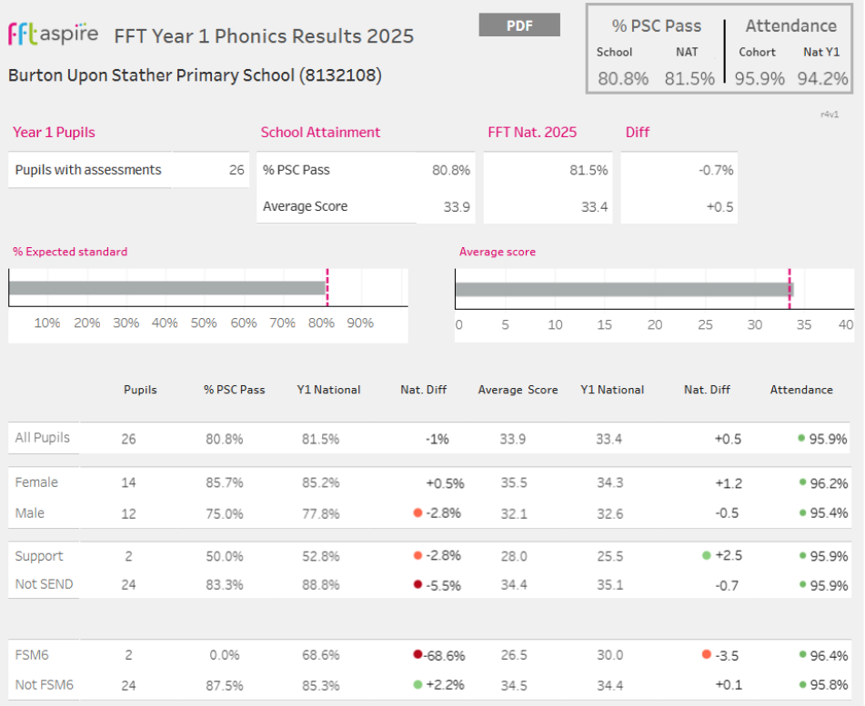
2025 outcomes:
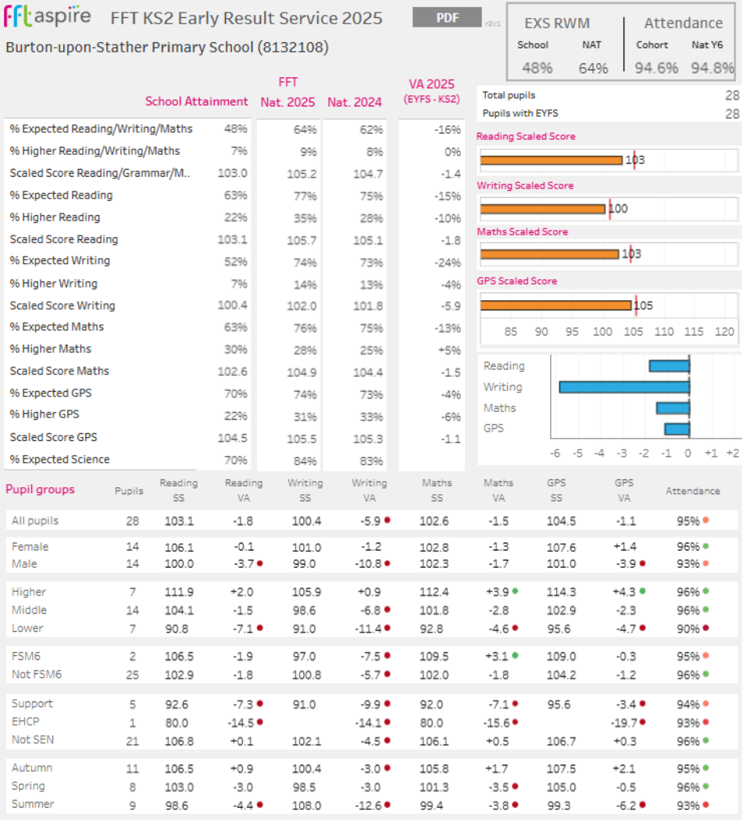
Externally provided programmes
Programme | Provider
TT Rockstars | Maths circle ltd
Spelling Shed | Ed Shed
Math Shed | Ed Shed
Get Ahead | Get Ahead Partnership
Number stacks

